**Experiment 1**

**Objective:** Design a simple web page with head, body and footer, with heading tags, image tag (your CV).

**Program : 1_My_CV.html**

<!DOCTYPE html>

<html>

<head>

    <title>My CV</title>

</head>

<body>

    <header>

        <h1>Mukund Patidar</h1>

        <p>Persuing BCA</p>

    </header>

    <main>

        <h2>Skill Set</h2>

        <ul>

            <li>C/C++</li>

            <li>Java</li>

            <li>HTML/CSS/JS</li>

        </ul>

        <h2>Education</h2>

        <table border="2">

            <tr>

                <th>S.No.</th>

                <th>Board of Education</th>

                <th>Class</th>

                <th>Percentage</th>

                <th>Year of passing</th>

            </tr>

            <tr>

                <td>1.</td>

                <td>MP Board of Secondary Education, Bhopal</td>

                <td>10th</td>

                <td>83.00%</td>

                <td>2021</td>

            </tr>

            <tr>

                <td>2.</td>

                <td>MP Board od Secondary Education, Bhopal</td>

                <td>12th</td>

                <td>56.00%</td>

                <td>2023</td>

            </tr>

        </table>

    </main>

    <footer>

        <p>Mobile number: 6260358378</p>

        <p>email: mukundpatidar1219@gmail.com</p>

        <p>Address: 85, Kaushalyapuri, Indore, Madhya Pradesh 452001</p>

    </footer>

</body>

</html>

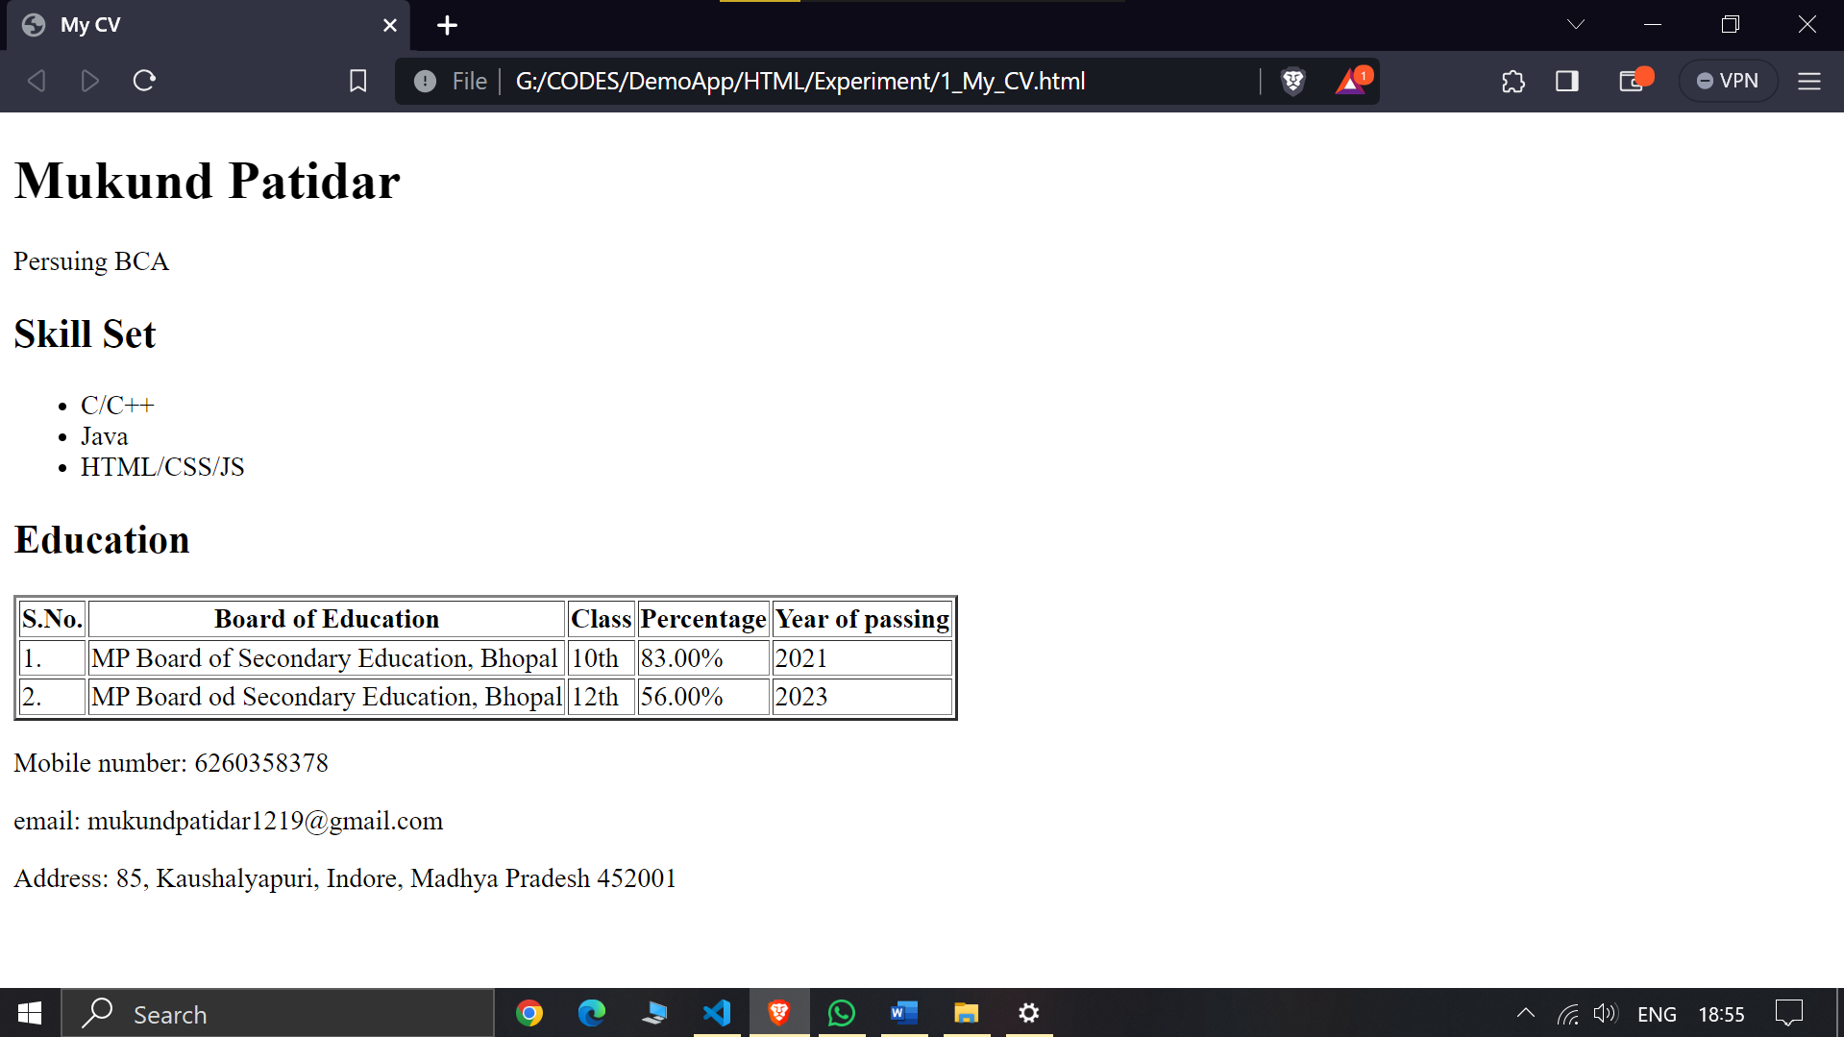**Output:**

**Experiment 2**

**Objective:** Design a web site for book information, home page should contain books list, when particular book is clicked, information of the books should display in the next page. (Use <a> tag for )

**Program : 2_Book.html**

<!DOCTYPE html>

<html>

<head>

    <title>Books</title>

</head>

<body>

    <h1>Book List</h1>

    <ul>

        <li><a href="book1.html">RICH DAD POOR DAD</a></li>

        <li><a href="book2.html">THE PSYCHOLOGY OF MONEY</a></li>

        <li><a href="book3.html">THINK LIKE A MONK</a></li>

    </ul>

</body>

</html>

**Program : book1.html**

<!DOCTYPE html>

<html>

<head>

    <title>Book Information</title>

</head>

<body>

    <h1>RICH DAD POOR DAD</h1>

    <img src="./Images to display/rdp.jpg" width="200" >

    <p>Author : Robert T. Kiyosaki and Sharon L. Lechter</p>

    <p>Published : 1997</p>

    <p>ISBN : 978-1-61268-019-4</p>

    <a href="2_Book.html">Go back to Book List</a>

</body>

</html>

**Program : book2.html**

<!DOCTYPE html>

<html>

<head>

    <title>Book Information</title>

</head>

<body>

    <h1>THE PSYCHOLOGY OF MONEY</h1>

    <img src="./Images to display/thePM.jpg" width="200" >

    <p>Author : Dr. Vishal Krishna Singh</p>

    <p>Published : September 2020</p>

    <p>ISBN : 978-93-90166-26-8</p>

    <a href="2_Book.html">Go back to Book List</a>

</body>

</html>

**Program : book3.html**

<!DOCTYPE html>

<html>

<head>

    <title>Book Information</title>

</head>

<body>

    <h1>THINK LIKE A MONK</h1>

    <img src="./Images to display/TLM.jpg" width="200" >

    <p>Author : Jay Shetty</p>

    <p>Published : September 2020</p>

    <p>ISBN : 978-93-93559-69-2</p>

    <a href="2_Book.html">Go back to Book List</a>

</body>

</html>

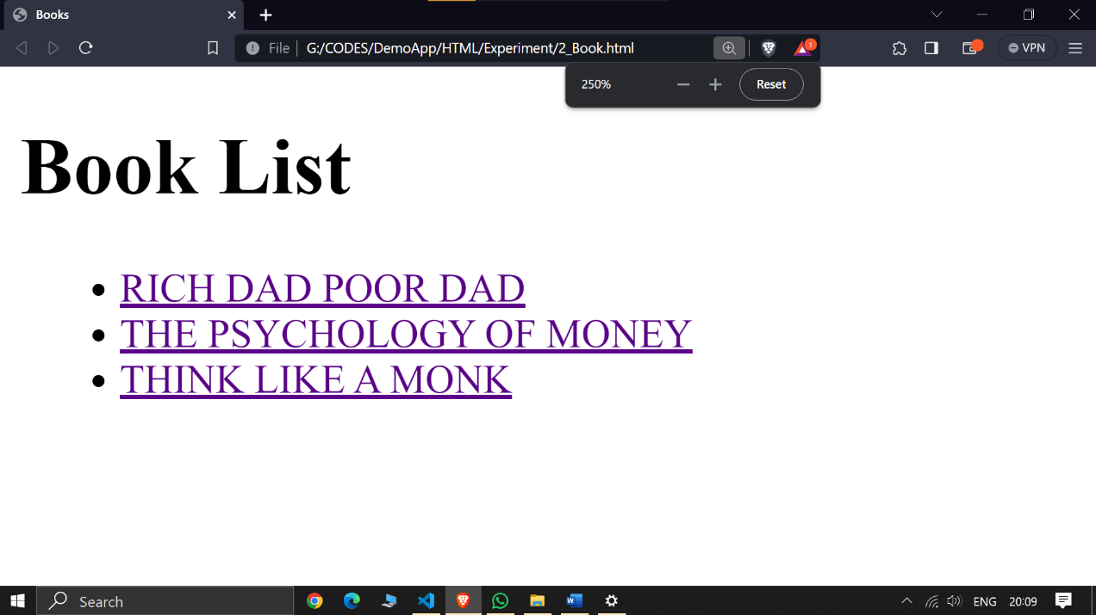**Output: Books**

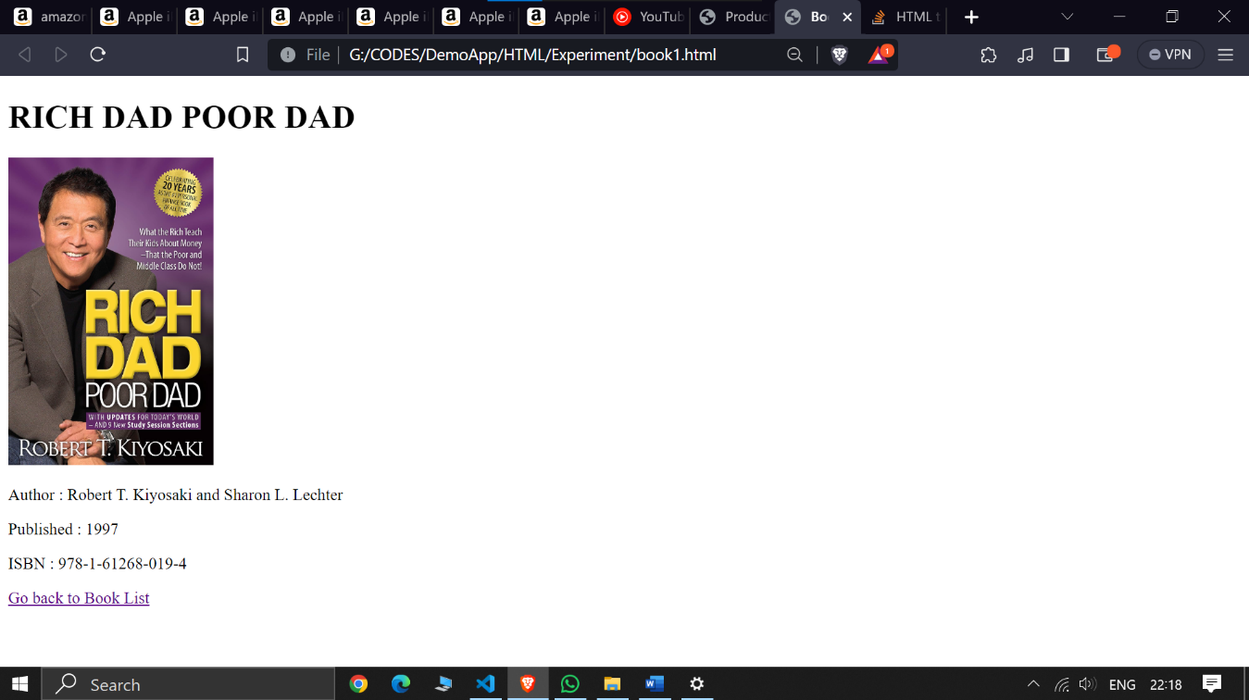**Output: book1 page**

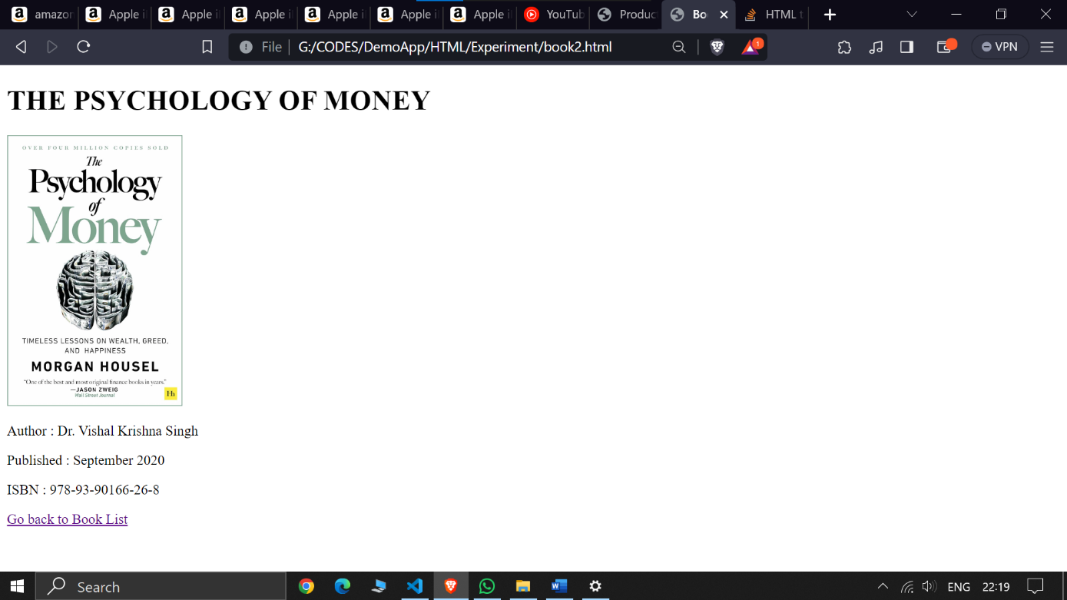

**Output: book2 page**

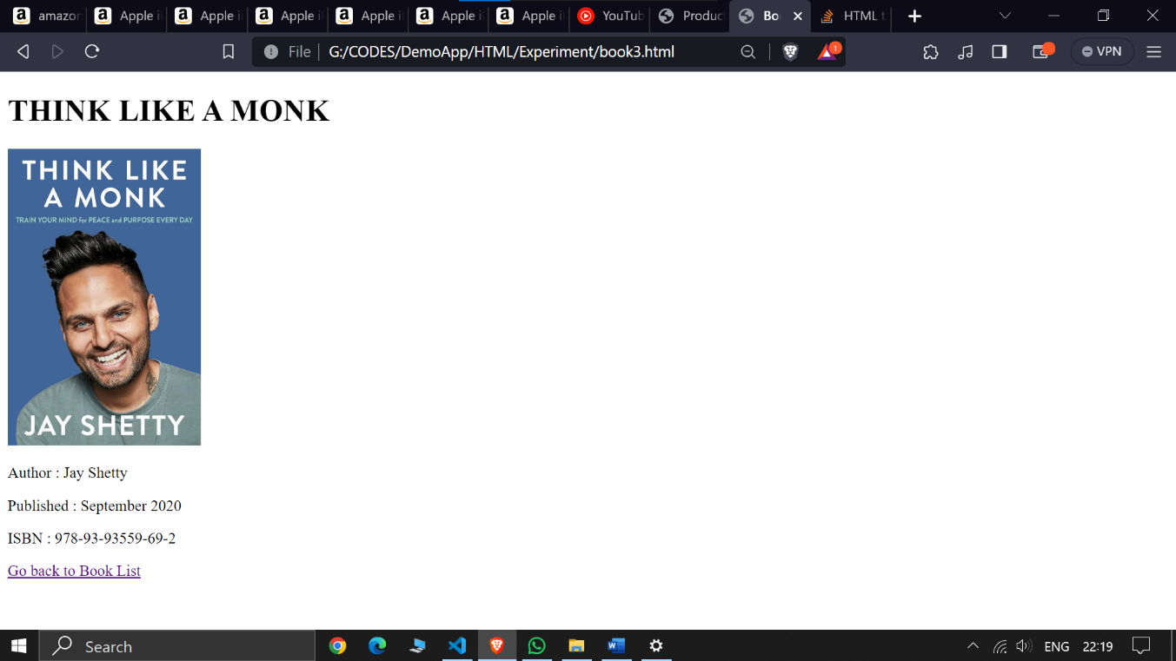

**Output: book3 page**

**Experiment 3**

**Objective:** 3. Design a page to display the product information such as name, brand, price and etc. on home page and when a product is clicked the description of the product will be displayed.

**Program : 3_Products.html**

<!DOCTYPE html>

<html>

<head>

    <title>Product Grid</title>

    <link rel="stylesheet" type="text/css" href="Product_styles.css">

</head>

<body>

    <div class="product-grid">

        <div class="product">

            <a href="Product1.html">

                <h2>Apple iPhone</h2>

                <img src="./Images to display/iphone 15 ++.jpg" width="200" >

            </a>

            <p class="description">iPhone 15 Pro Max</p>

            <p class="price">₹ 1,56,990</p>

        </div>

        <div class="product">

            <a href="Product2.html">

                <h2>Apple iPhone</h2>

                <img src="./Images to display/iphone 15 +.jpg" width="200" >

            </a>

            <p class="description">iPhone 15 Pro</p>

            <p class="price">₹ 1,41,990</p>

        </div>

        <div class="product">

            <a href="Product3.html">

                <h2>Apple iPhone</h2>

                <img src="./Images to display/iphone 15.jpg" width="200" >

            </a>

            <p class="description">iPhone 15</p>

            <p class="price">₹ 76,990</p>

        </div>

        <div class="product">

            <a href="Product4.html">

                <h2>Apple iPhone</h2>

                <img src="./Images to display/iphone 14 +.jpg" width="200" >

            </a>

            <p class="description">iPhone 14 Pro</p>

            <p class="price">₹ 1,39,900</p>

        </div>

        <div class="product">

            <a href="Product5.html">

                <h2>Apple iPhone</h2>

                <img src="./Images to display/iphone 14 p.jpg" width="200" >

            </a>

            <p class="description">iPhone 14 Plus</p>

            <p class="price">₹ 69,999</p>

        </div>

        <div class="product">

            <a href="Product6.html">

                <h2>Apple iPhone</h2>

                <img src="./Images to display/iphone 14.jpg" width="200" >

            </a>

            <p class="description">iPhone 14</p>

            <p class="price">₹ 71,999</p>

        </div>

    </div>

</body>

</html>

**Program : Product1.html**

<!DOCTYPE html>

<html>

<head>

    <title>Apple iphone</title>

    <style>

        td{ padding: 0 40px; }

        th{ text-align: left; }

        h2{ color: #7e0d0d; }

      </style>

</head>

<body>

    <h1>Apple iPhone 15 Pro Max</h1>

    <img src="./Images to display/iphone 15 ++.jpg" width="200">

    <h2>₹ 1,56,990</h2>

    <table>

        <tr>

            <th>Brand</th>

            <td>Apple</td>

        </tr>

        <tr>

            <th>Modle Name</th>

            <td>iPhone 15 pro max</td>

        </tr>

        <tr>

            <th>Color</th>

            <td>Natural Titanium</td>

        </tr>

        <tr>

            <th>Storage</th>

            <td>256 GB</td>

        </tr>

        <tr>

            <th>Ram</th>

            <td>8 GB</td>

        </tr>

    </table>

    <a href="3_Products.html">Back to Product Grid</a>

</body>

</html>

**Program : Product2.html**

<!DOCTYPE html>

<html>

<head>

    <title>Apple iphone</title>

    <style>

        td{ padding: 0 40px; }

        th{ text-align: left; }

        h2{ color: #7e0d0d; }

      </style>

</head>

<body>

    <h1>Apple iPhone 15 Pro</h1>

    <img src="./Images to display/iphone 15 +.jpg" width="200">

    <h2>₹ 1,41,990</h2>

    <table>

        <tr>

            <th>Brand</th>

            <td>Apple</td>

        </tr>

        <tr>

            <th>Modle Name</th>

            <td>iPhone 15 pro</td>

        </tr>

        <tr>

            <th>Color</th>

            <td>Blue Titanium</td>

        </tr>

        <tr>

            <th>Storage</th>

            <td>256 GB</td>

        </tr>

        <tr>

            <th>Ram</th>

            <td>8 GB</td>

        </tr>

    </table>

    <a href="3_Products.html">Back to Product Grid</a>

</body>

</html>

**Program : Product3.html**

<!DOCTYPE html>

<html>

<head>

    <title>Apple iphone</title>

    <style>

        td{ padding: 0 40px; }

        th{ text-align: left; }

        h2{ color: #7e0d0d; }

      </style>

</head>

<body>

    <h1>Apple iPhone 15</h1>

    <img src="./Images to display/iphone 15.jpg" width="200">

    <h2>₹ 76,990</h2>

    <table>

        <tr>

            <th>Brand</th>

            <td>Apple</td>

        </tr>

        <tr>

            <th>Modle Name</th>

            <td>iPhone 15</td>

        </tr>

        <tr>

            <th>Color</th>

            <td>Blue</td>

        </tr>

        <tr>

            <th>Storage</th>

            <td>128 GB</td>

        </tr>

        <tr>

            <th>Ram</th>

            <td>6 GB</td>

        </tr>

    </table>

    <a href="3_Products.html">Back to Product Grid</a>

</body>

</html>

**Program : Product4.html**

<!DOCTYPE html>

<html>

<head>

    <title>Apple iphone</title>

    <style>

        td{ padding: 0 40px; }

        th{ text-align: left; }

        h2{ color: #7e0d0d; }

      </style>

</head>

<body>

    <h1>Apple iPhone 14 pro</h1>

    <img src="./Images to display/iphone 14 +.jpg" width="200">

    <h2>₹ 1,39,900</h2>

    <table>

        <tr>

            <th>Brand</th>

            <td>Apple</td>

        </tr>

        <tr>

            <th>Modle Name</th>

            <td>iPhone 14 pro</td>

        </tr>

        <tr>

            <th>Color</th>

            <td>Gold</td>

        </tr>

        <tr>

            <th>Storage</th>

            <td>256 GB</td>

        </tr>

        <tr>

            <th>Ram</th>

            <td>8 GB</td>

        </tr>

    </table>

    <a href="3_Products.html">Back to Product Grid</a>

</body>

</html>

**Program : Product5.html**

<!DOCTYPE html>

<html>

<head>

    <title>Apple iphone</title>

    <style>

        td{ padding: 0 40px; }

        th{ text-align: left; }

        h2{ color: #7e0d0d; }

      </style>

</head>

<body>

    <h1>Apple iPhone 14 plus</h1>

    <img src="./Images to display/iphone 14 p.jpg" width="200">

    <h2>₹ 69,999</h2>

    <table>

        <tr>

            <th>Brand</th>

            <td>Apple</td>

        </tr>

        <tr>

            <th>Modle Name</th>

            <td>iPhone 14 plus</td>

        </tr>

        <tr>

            <th>Color</th>

            <td>Yellow</td>

        </tr>

        <tr>

            <th>Storage</th>

            <td>128 GB</td>

        </tr>

        <tr>

            <th>Ram</th>

            <td>6 GB</td>

        </tr>

    </table>

    <a href="3_Products.html">Back to Product Grid</a>

</body>

</html>

**Program : Product6.html**

<!DOCTYPE html>

<html>

<head>

    <title>Apple iphone</title>

    <style>

        td{ padding: 0 40px; }

        th{ text-align: left; }

        h2{ color: #7e0d0d; }

      </style>

</head>

<body>

    <h1>Apple iPhone 14</h1>

    <img src="./Images to display/iphone 14.jpg" width="200">

    <h2>₹ 71,999</h2>

    <table>

        <tr>

            <th>Brand</th>

            <td>Apple</td>

        </tr>

        <tr>

            <th>Modle Name</th>

            <td>iPhone 14</td>

        </tr>

        <tr>

            <th>Color</th>

            <td>Red</td>

        </tr>

        <tr>

            <th>Storage</th>

            <td>256 GB</td>

        </tr>

        <tr>

            <th>Ram</th>

            <td>8 GB</td>

        </tr>

    </table>

    <a href="3_Products.html">Back to Product Grid</a>

</body>

</html>

**Program : Product_style.css**

body { font-family: Arial, sans-serif; }

.product-grid { display: grid;

                grid-template-columns: repeat(3, 1fr);

                gap: 20px;

                padding: 20px; }

.product {  text-align: center;

            background-color: #eee6e694;

            padding: 20px;

            border: 1px solid #ddd;

            border-radius: 5px; }

.product img { max-width: 100%; }

.price { color: #7e0d0d;

         font-weight: bold; }

a { text-decoration: none;

    color: #333; }

img{ height: 300px;

     width: 300px; }

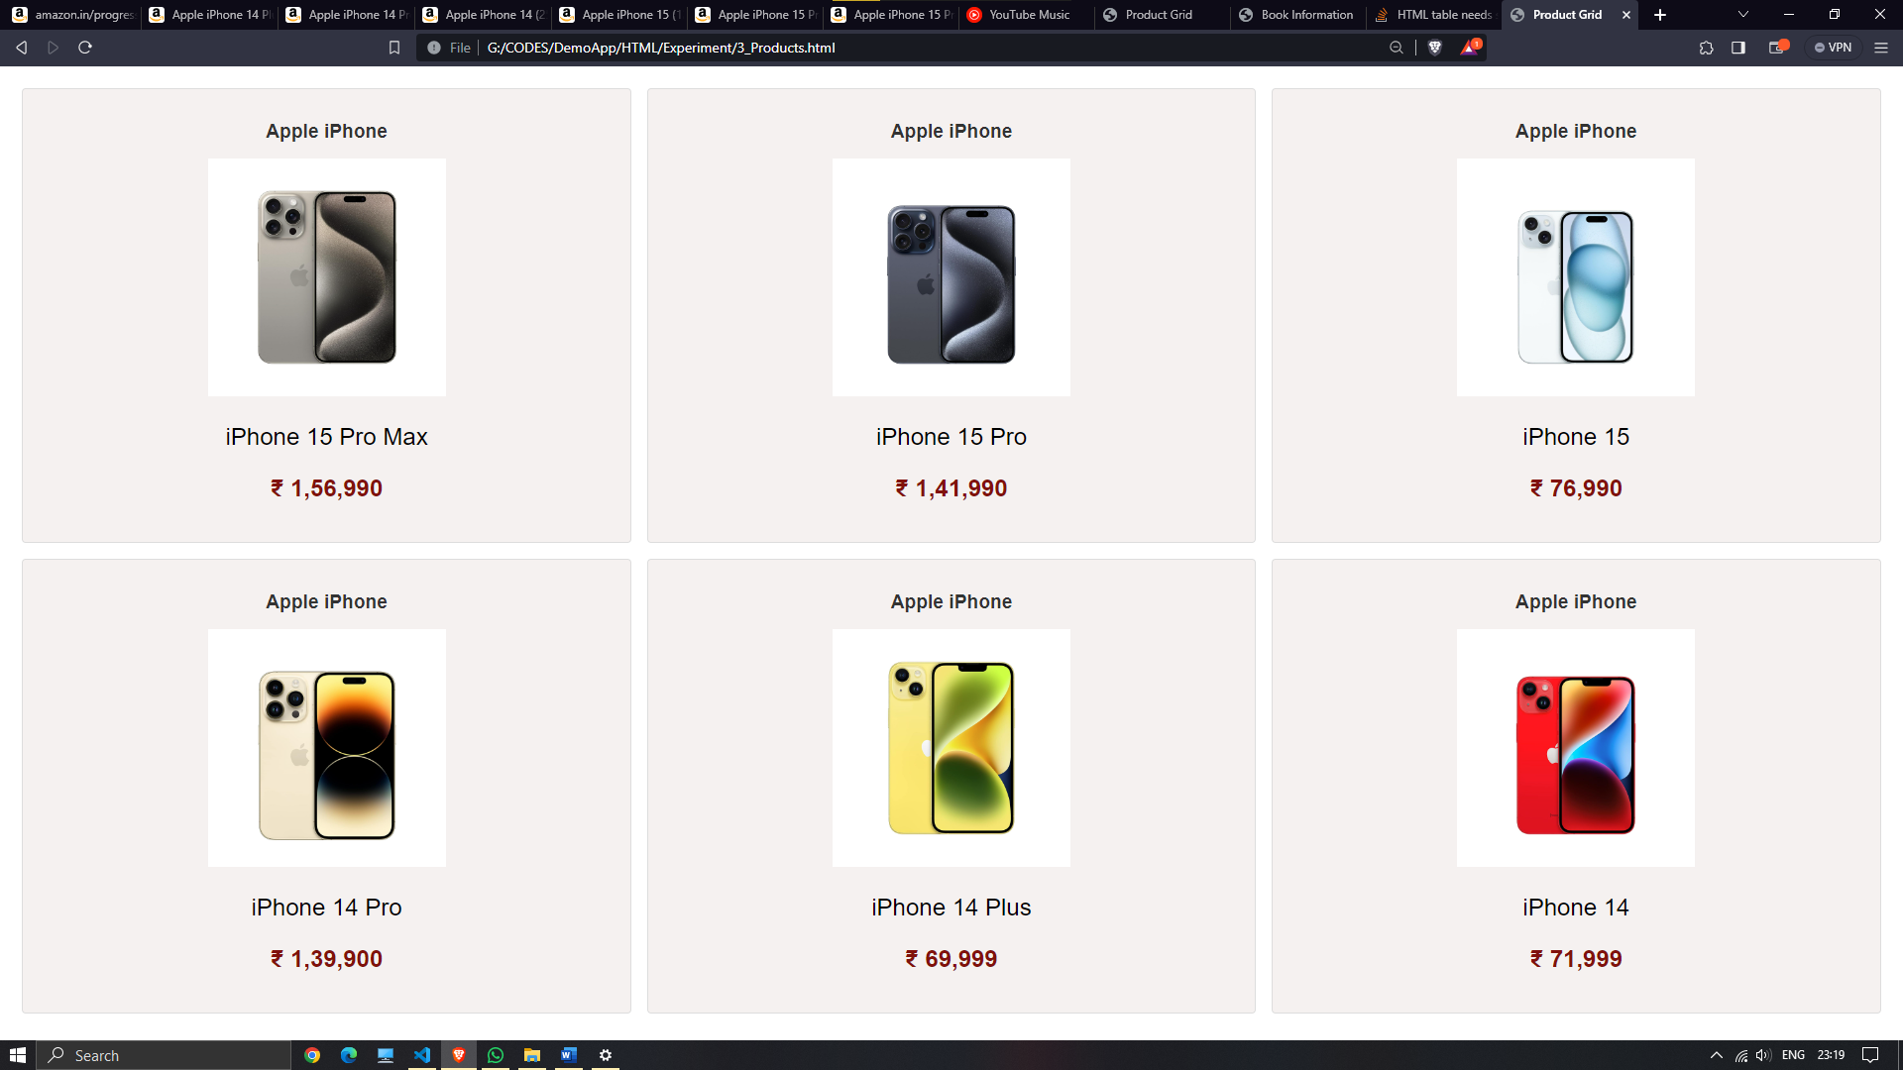**Output: Product Grid Page**

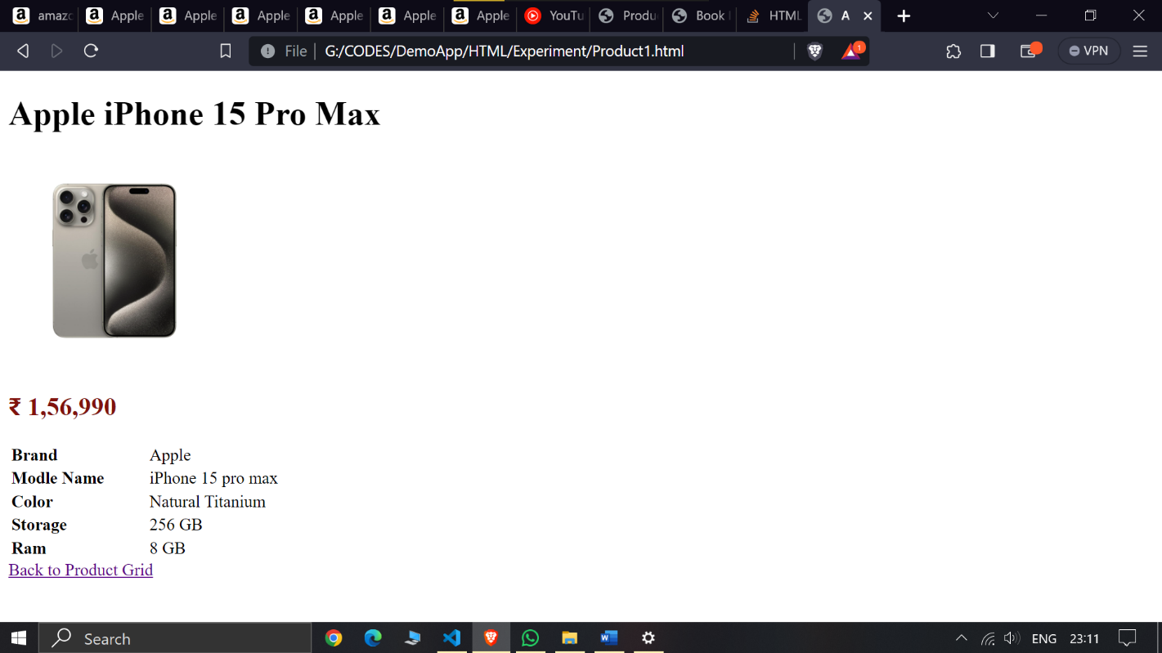**Output: Product1 Page**

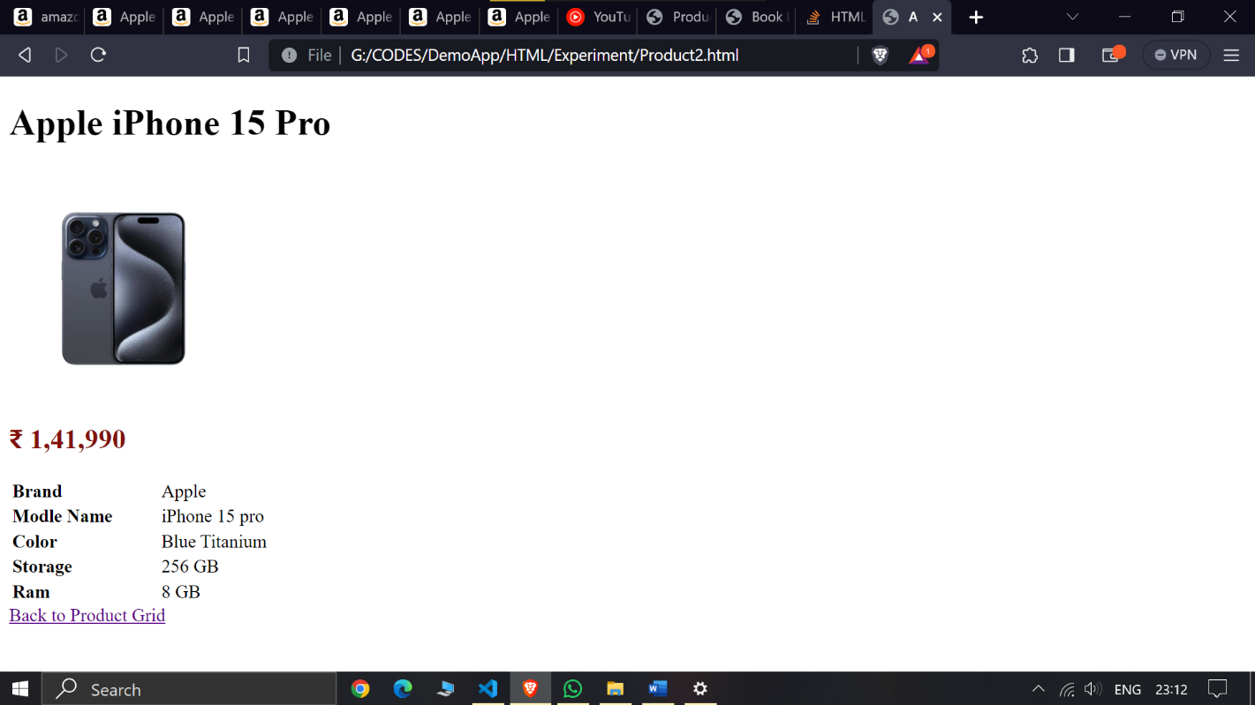

**Output: Product2 Page**

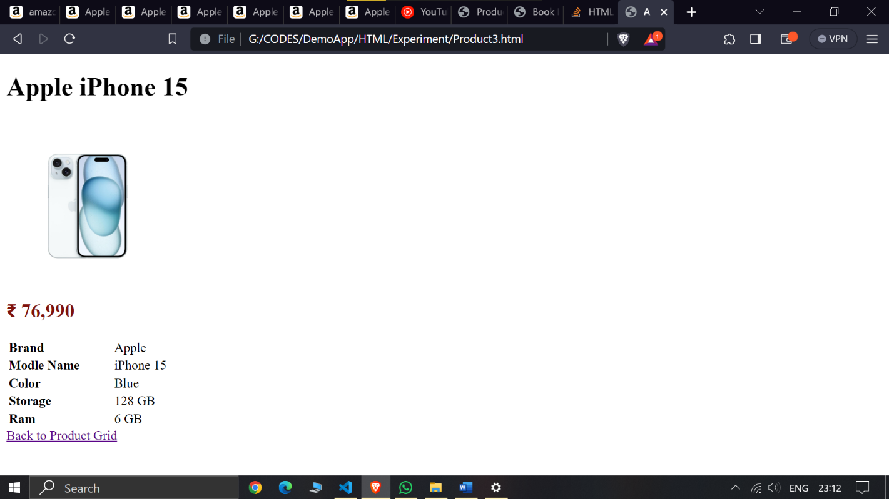

**Output: Product3 Page**

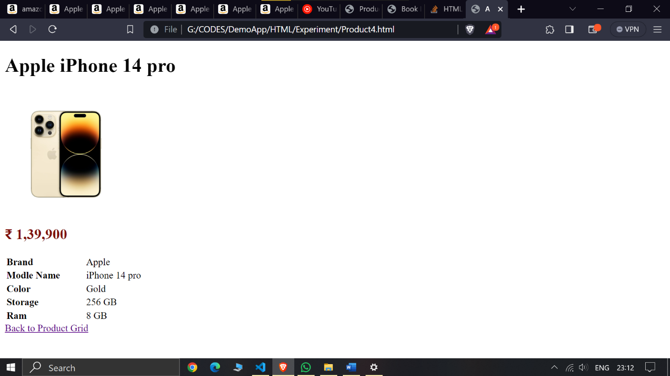**Output: Product4 Page**

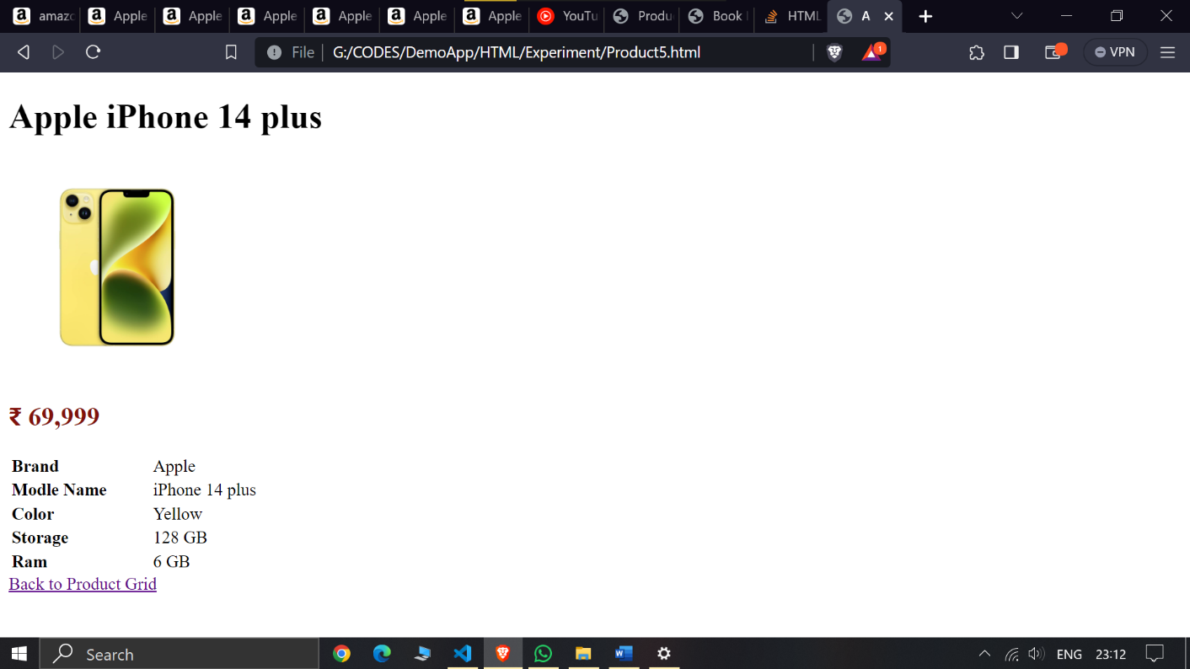

**Output: Product5 Page**

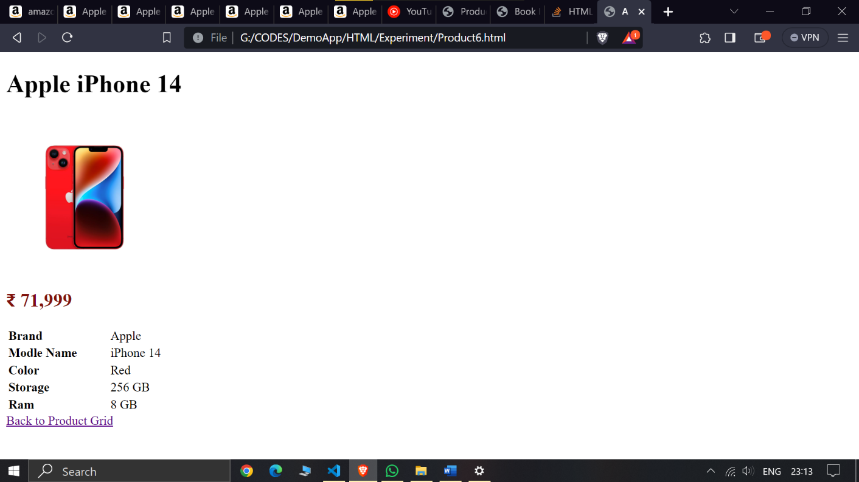

**Output: Product6 Page**